CLASS ROOM ACTIVITY – ANSWERS

Subject: Data Warehousing and Data Mining

1. Create a Sales Data Warehouse
Unit I – Data Warehousing
Aim: Create a sales dataset, identify the fact and dimension tables, draw a star schema, and state two questions the warehouse can answer.

Sales dataset (10 records)
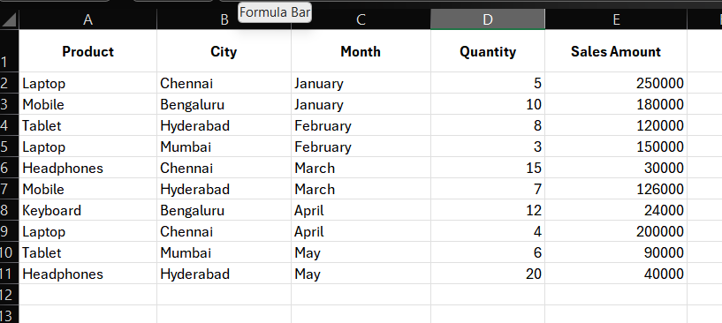

Fact table and dimension tables:

Fact table: Fact_Sales. It stores measurable values (Quantity and Sales_Amount) and keys linking to the dimensions.
Fact_Sales columns: Sales_ID, Product_ID, City_ID, Month_ID, Quantity, Sales_Amount.
Dimension tables:
- Dim_Product: Product_ID (primary key), Product_Name.
- Dim_City: City_ID (primary key), City_Name.
- Dim_Month: Month_ID (primary key), Month_Name.

C. Simple star schema:
Dim_Product
|
Dim_City —— Fact_Sales —— Dim_Month
|
Measures: Quantity, Sales_Amount
Fact_Sales is at the centre and connects directly to Dim_Product, Dim_City and Dim_Month through their ID keys.

D. Two questions the warehouse can answer:

1. What is the total sales amount for each product?
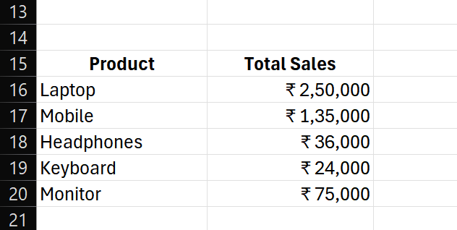
2. Which city has the highest total sales amount in a selected month?
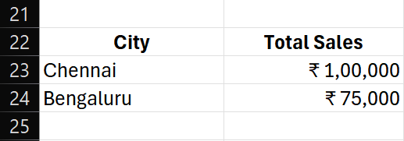

2. Data Cleaning Challenge:
Unit II – Data Preprocessing
Aim: Identify data quality problems, remove duplicates, handle missing values and submit the corrected dataset.

Original customer dataset (10 records)
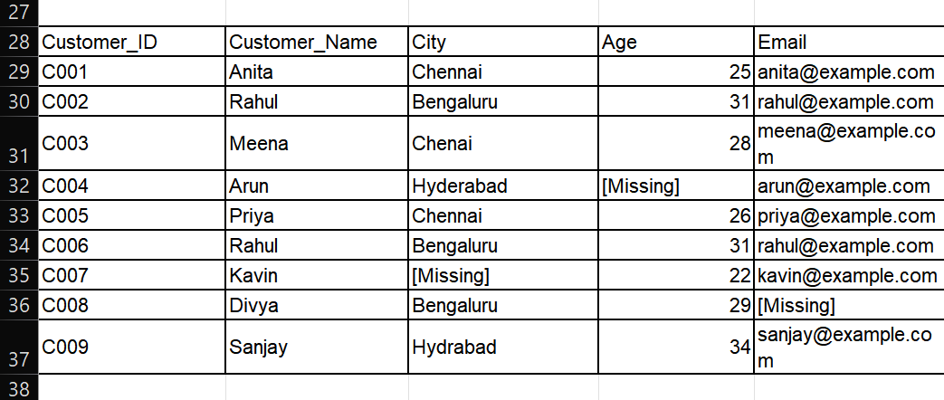

B. Data quality problems identified
- Duplicate: C006 repeats the details of C002 (Rahul, Bengaluru, age 31, same email).
- Spelling error: 'Chenai' should be 'Chennai'.
- Spelling error: 'Hydrabad' should be 'Hyderabad'.
- Missing value: Age is missing for C004 (Arun).
- Missing value: City is missing for C007 (Kavin).
- Missing value: Email is missing for C008 (Divya).

C. Data cleaning steps
- Remove duplicate record C006 and retain C002.
- Correct 'Chenai' to 'Chennai'.
- Correct 'Hydrabad' to 'Hyderabad'.
- Fill Arun's missing age with 28, the median of the available ages.
- Set Kavin's missing city to 'Unknown' because the actual city cannot be inferred.
- Set Divya's missing email to 'Not provided' because the email is unavailable.

Corrected customer dataset (9 unique records)
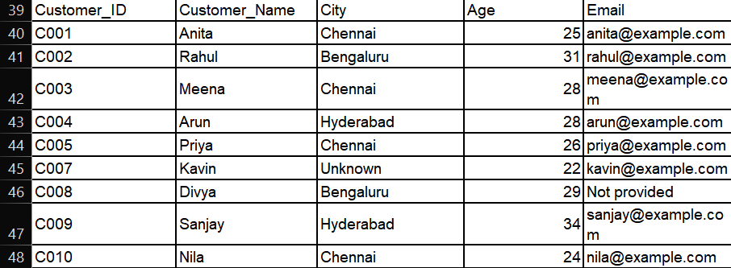

Conclusion:
A sales warehouse was designed using one fact table and three dimension tables in a star schema. The customer dataset was cleaned by removing a duplicate, correcting spelling errors and handling missing values.

